**MULTIMEDIA DIGITAL INFORMASI BOARD PRIME**

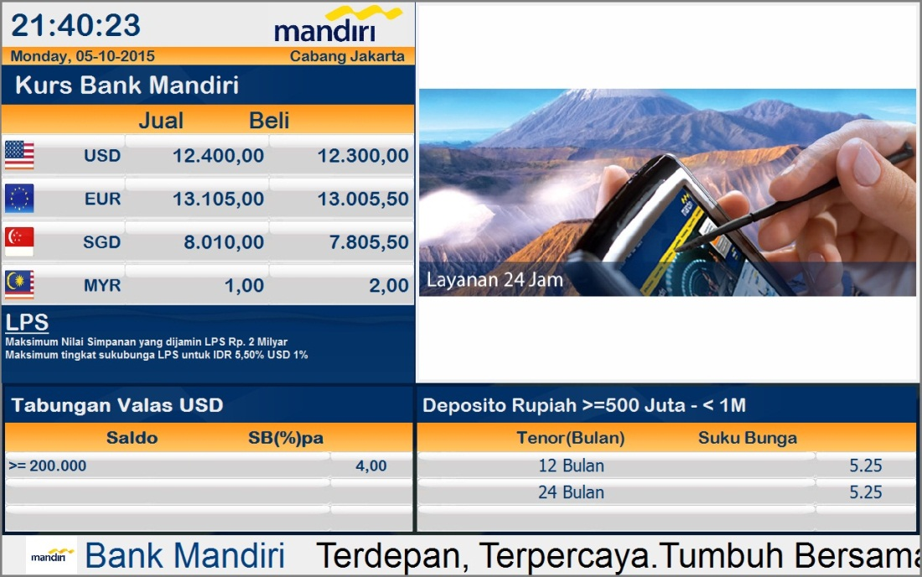

**Contoh Tampilan Display LED TV**

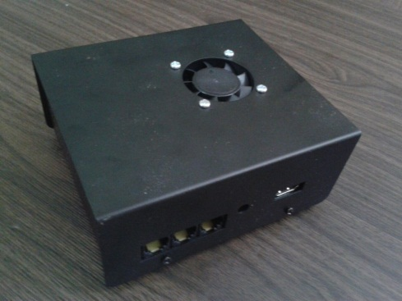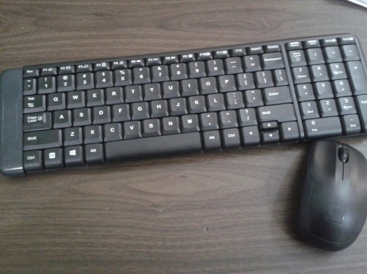

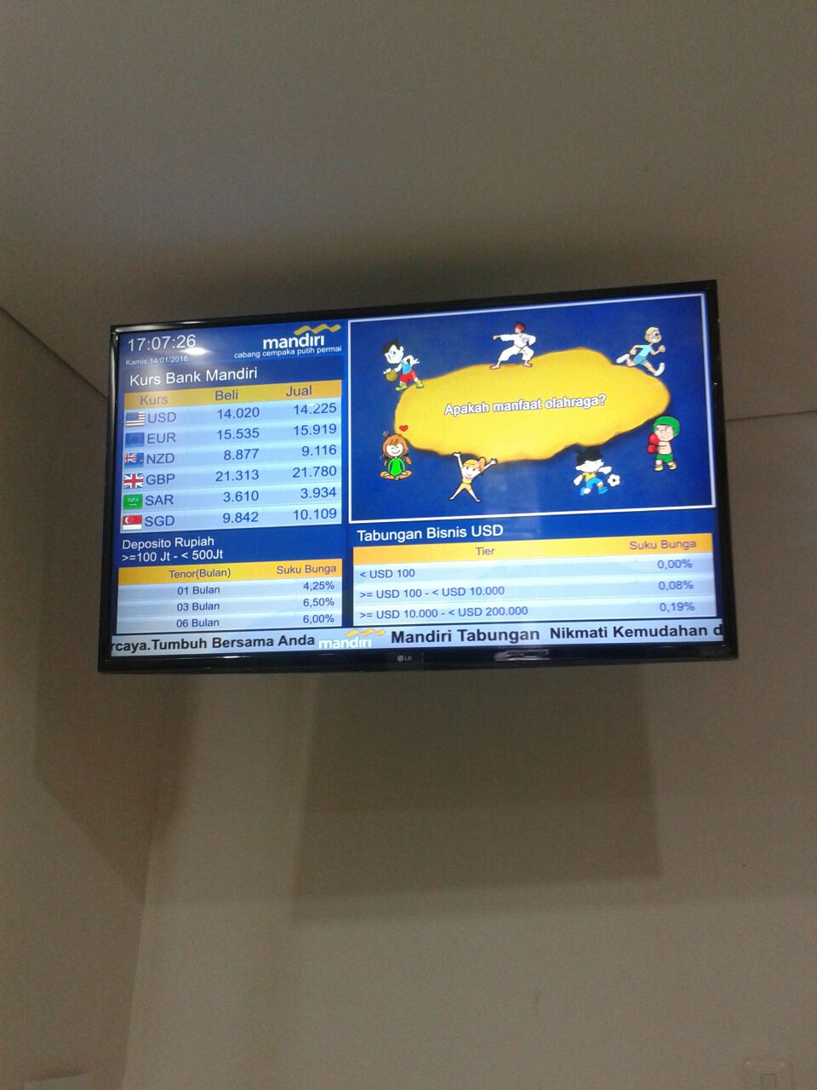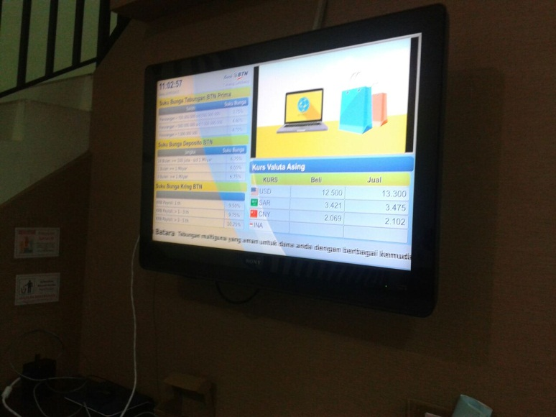 **Mouse dan Keyboard Wireless**  **Modul Controller**

**MULTIMEDIA DIGITAL INFORMASI BOARD PRIME**

Spesifikasi :

* Software Aplikasi
* Modul Controller
* LED TV
* Kabel VGA, LAN
* Aksesories
* Logo
* Running Text/ Moving Sign
* Video Iklan / TV Lokal (Optional)
* Time and Date
* Controller by Keyboard and Mouse (Include)

 **Distributed by :**

**PT. HUTAMA RAHARJA DELLADA**

**Perkantoran Villa Gading Indah Blok A1 No. 9-10**

**Jl. Boulevard Bukit Gading Raya, Kelapa Gading - Jakarta Utara**

**Phone : (62-21) 4509260 Fax : (62 21) 4509261 Website : www.pthrd.co.id**