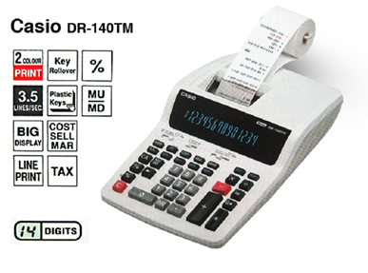
Specifications

2-Colour Printing
Positive values are shown in black, and negative values are shown in read for easy checking.
3.5 line-per-second printing
The value indicates the number of lines printed per seconds.
Large display
Large, easy-to-read display.
Line printing
Line printing for higher speed, superior print quality, and quieter operation.
Key Rollover
Key operations are buffered, so nothing is lost even during high-speed input.
Plastic Keys
Designed and engineered for easy operation.
Cost/Sell/Margin
Tax calculation
Automatic calculation and printout of price plus tax, price less tax, discount, selling price, tax amout, discount amount, and margin amount.
Profit Margin Percent
% key gives quick access to prices and profit, and also delivres add-ons, discounts, ratios, increase/decrease values and regular percentages.
Mark-Up / Mark-Down
All the mark-up / mark-downcapabilities of an adding machine for simplified cost and profit calculaions..

