DM-1600TV
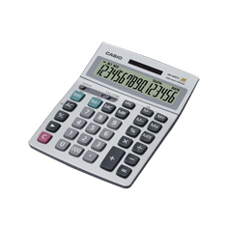
- Desk-Top Type
- 35.5(H) × 155(W) × 210(D) mm
- 16 Digits
- Extra Large display
Larger display makes more data easier to read.
- Two-way power (Solar + Battery)
Solar powered when light is sufficient, battery powered when light is insufficient.
- Key rollover
Key operations are stored in a buffer, so nothing is lost even during high-speed input.
- Plastic keys
Designed and engineered for easy operation.
- Durable metal Faceplate
Tough cover stands up to rough treatment.
- Tax calculation
Automatic calculation of price plus tax, price less tax, discount, selling price, tax amount, discount amount, and margin amount.
- Regular percent
Regular percentage calculations.
Distributed by :
PT. HUTAMA RAHARJA DELLADA
Perkantoran Villa Gading Indah Blok A1 No. 9-10
Jl. Boulevard Bukit Gading Raya, Kelapa Gading - Jakarta Utara
Phone : (62-21) 4509260 Fax : (62 21) 4509261 Website : www.pthrd.co.id

DH-16-BK
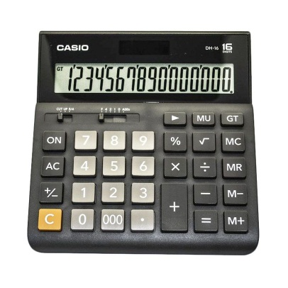

Extra Large displayLarger display makes more data easier to read.
Two-way power (Solar + Battery)Solar powered when light is sufficient, battery powered when light is insufficient.Key rolloverKey operations are stored in a buffer, so nothing is lost even during high-speed input.
Plastic keys Designed and engineered for easy operation.
Regular percentRegular percentage calculations.
Mark-upAll the mark-up capabilities of an adding machine for simplified cost and profi.

Distributed by :
PT. HUTAMA RAHARJA DELLADA
Perkantoran Villa Gading Indah Blok A1 No. 9-10
Jl. Boulevard Bukit Gading Raya, Kelapa Gading - Jakarta Utara
Phone : (62-21) 4509260 Fax : (62 21) 4509261 Website : www.pthrd.co.id

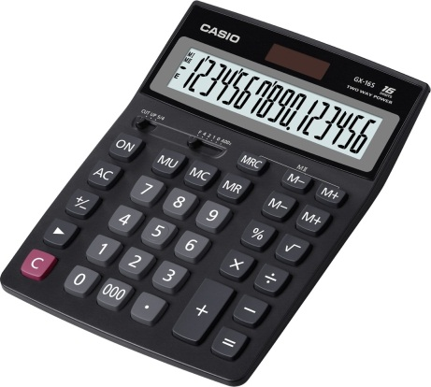
GX-16S

- Extra Large display
Larger display makes more data easier to read.
- Two-way power (Solar + Battery)
Solar powered when light is sufficient, battery powered when light is insufficient.
- Key rollover
Key operations are stored in a buffer, so nothing is lost even during high-speed input.
- Plastic keys
Designed and engineered for easy operation.
- Regular percent
Regular percentage calculations.
- Mark-up
All the mark-up capabilities of an adding machine for simplified cost and profit calculations.

Distributed by :
PT. HUTAMA RAHARJA DELLADA
Perkantoran Villa Gading Indah Blok A1 No. 9-10
Jl. Boulevard Bukit Gading Raya, Kelapa Gading - Jakarta Utara
Phone : (62-21) 4509260 Fax : (62 21) 4509261 Website : www.pthrd.co.id

