CASH BOX
ICHIBAN D3000
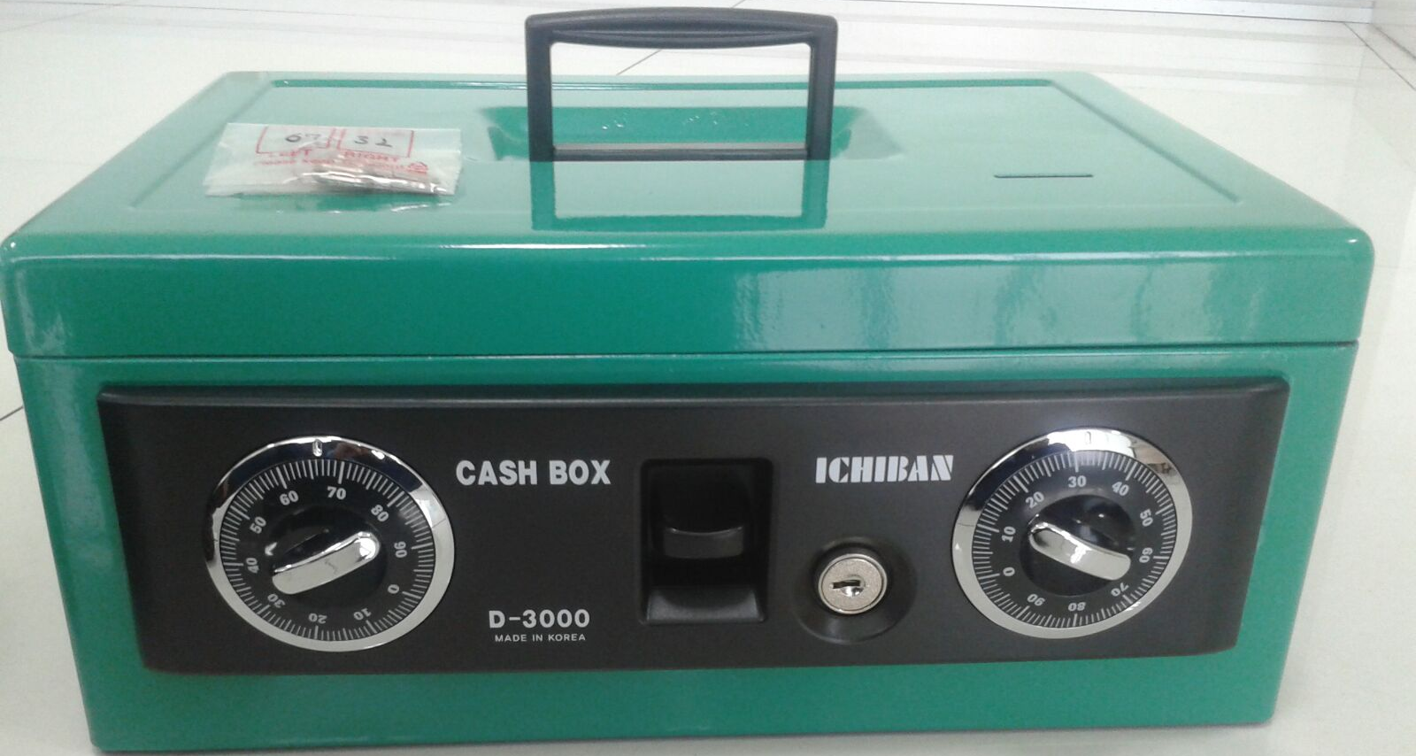

NEW WITH ALARM
Outside Dimension : W 361 mm x D 250 mm x H 156 mm
Authorized by:
PT. HUTAMA RAHARJA DELLADA
Perkantoran Villa Gading Indah Blok. A1 No. 9-10
Jl. Boulevar Bukit Gading Raya, Kelapa Gading, Jakarta Utara
Telp. 021-4509260 (Hunting) Fax. 021-4509261 Email. info@pt-hrd.co.id
Website. www.pt-hrd.co.id

